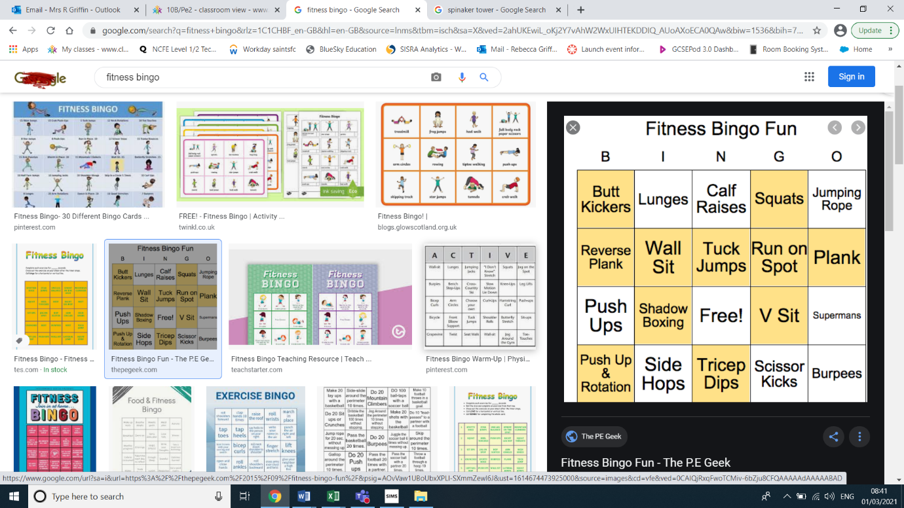

Write down all of the exercises below onto separate pieces of paper and pick these out at random.

Firstly, can you try and complete 1 horizontal line!

Then, can you try and complete 2 horizontal lines!

Finally, continue your exercises until you complete your full house!

FITNESS ACTIVITY

FITNESS BINGO FUN!

**LEVEL 1: 15 SECONDS**

**LEVEL 2: 20 SECONDS**

**LEVEL 3: 30 SECONDS**

**EXTENSION TASKS:**

**COMPLETE WITH PEOPLE WITHIN YOUR HOUSEHOLD**

**CREATE YOUR OWN FITNESS BINGO EXERCISES**