The experiment is safe and very easy to do, but you might want to ask for help from an adult if you feel you need it.
The scientific question that you are going to be investigating is:
How does the surface area of a container affect the speed of evaporation of water?
Look out for yellow challenge questions to extend your learning!

Part 1: Research & Planning
Stuck?
Solid:
https://www.bbc.co.uk/bitesize/guides/z2wmxnb/revision/1
Liquid:
https://www.bbc.co.uk/bitesize/guides/z2wmxnb/revision/2
Gas:
https://www.bbc.co.uk/bitesize/guides/z2wmxnb/revision/3
Changes of state:
https://www.bbc.co.uk/bitesize/guides/z2wmxnb/revision/4
Evaporation:
https://www.bbc.co.uk/bitesize/topics/zkgg87h/articles/zydxmnb
- What is the chemical formula for water?
- What is evaporation?
- Draw a particle diagram for solid, liquid and gas

- Describe the movement of the particles in a liquid compared to a gas.
- In this experiment – what are you changing?
- In this experiment – what are you measuring?
- In this experiment – what are you keeping the same?
Challenge:
- Write a detailed method for your experiment
- Draw over the graph a sketch for an impure substance. Explain the difference between a pure substance and an impure substance.
- Explain the difference between evaporation and boiling.
Stuck?
Hint: Change the shape of your container (but remember to keep the same amount of water) to see how it changes the speed of evaporation of water
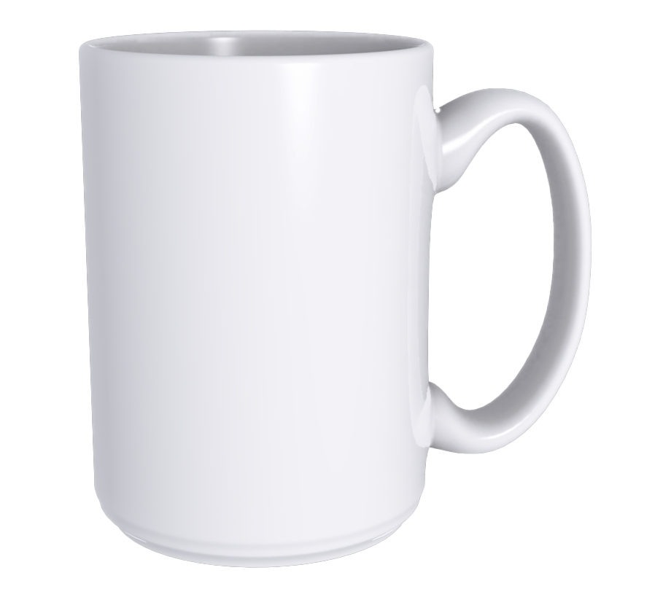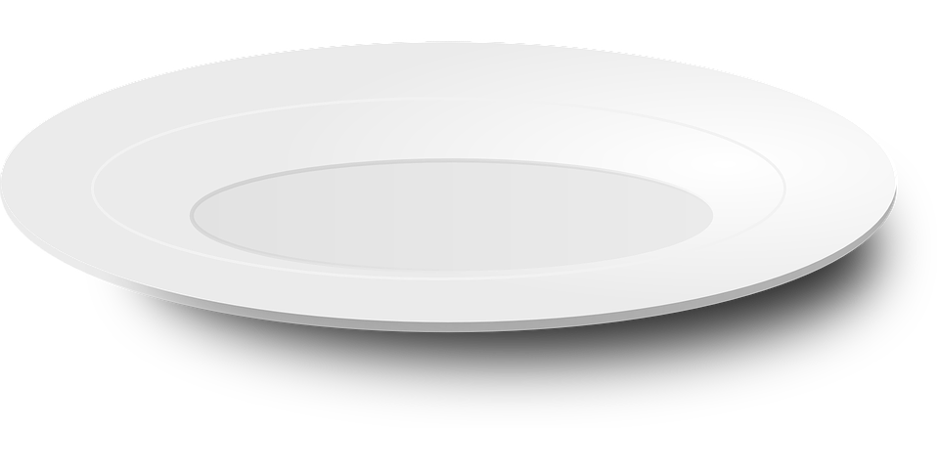
which one will 100ml of water evaporate the fastest?
How to plan an experiment
https://www.bbc.co.uk/bitesize/guides/zcxp6yc/revision/1

Part 2: Completing the experiment
Set up 5 different containers with the same amount of water in them – leave the water to evaporate and see how long it takes for the water to evaporate. Remember to ask an adult if you need any help. It might be a good idea to use a measuring jug to measure the difference in the water.
Please read the risk assessment:
What could go wrong? | How I will stop this risk happening
Spill water | If I spill any water, I will need to clean it up straight away and properly so no one will slip.
Trip over the containers | Place the containers up high, for example – on a windowsill. Or place them out of the way, for example – in the garden on a garden chair.
Fill out this table of results:
Container | How long it took for the water to evaporate
Example: Plate | 1 day
Challenge:
Repeat the experiment with warm water from the tap or a kettle (ask for help and make sure you do not burn yourself) and explain the results.

Part 3: Explaining the experiment
Now you have your results, lets see if we can explain them!

- Which container did the water evaporate the fastest? Why do you think this?
(2 marks)
- Which container did the water evaporate the slowest? Why do you think this is?
(2 marks)
Challenge:
Can you draw a graph of your results?
Why do scientists want to display their data in a graph?

